Base de datos:  
modelo conceptual – diagrama e-r

Modelo lógico – diagrama relacional

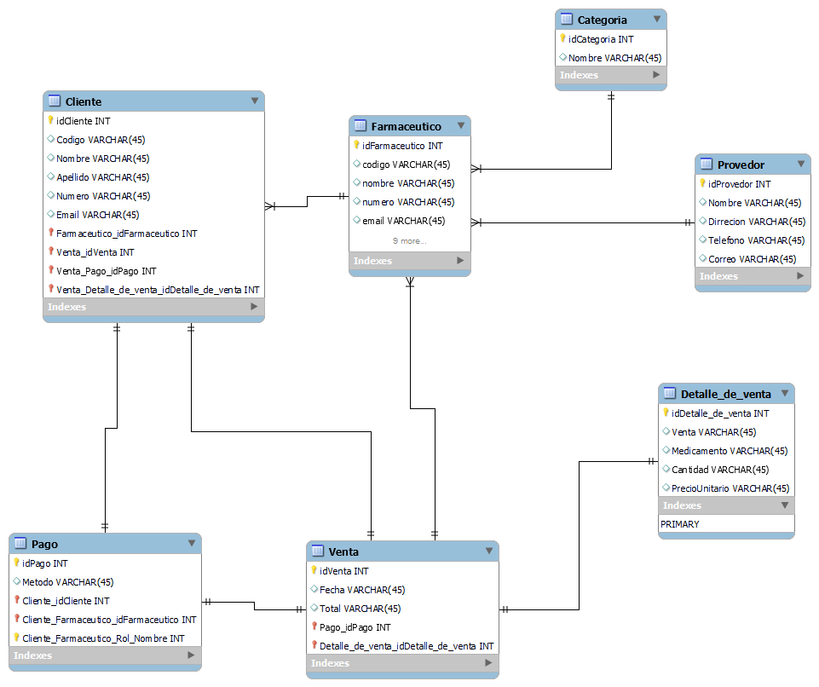

Modelo físico

* SGDB (MYSQL), tablas, campos, relaciones, pk,fk

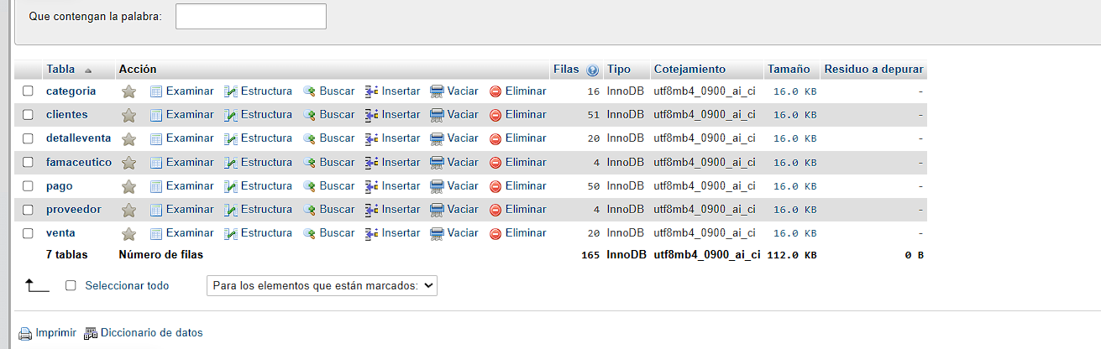

* Insertar datos (en la tabla principal 50 y otras a su criterio)

Cliente:

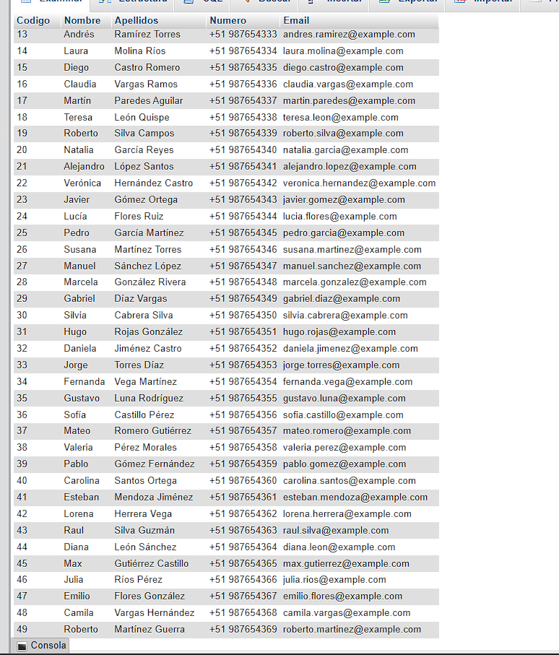

Categoria:

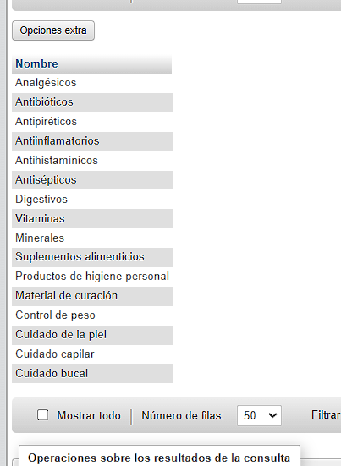

Detalleventa:

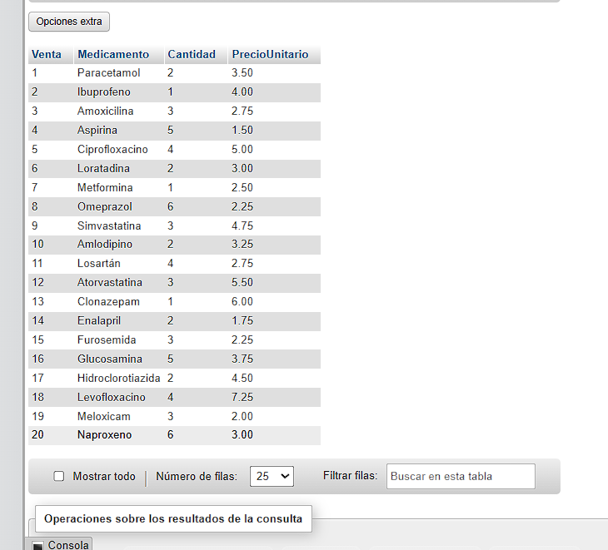

Farmaceutico:

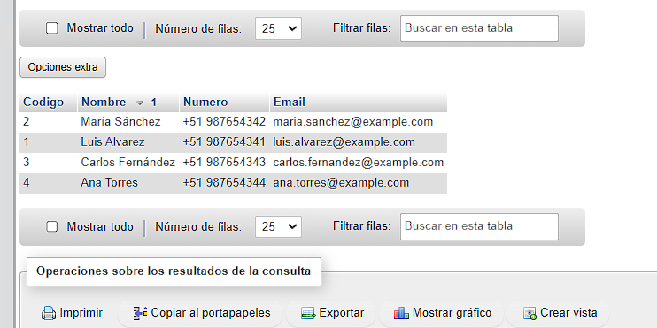

Pago:

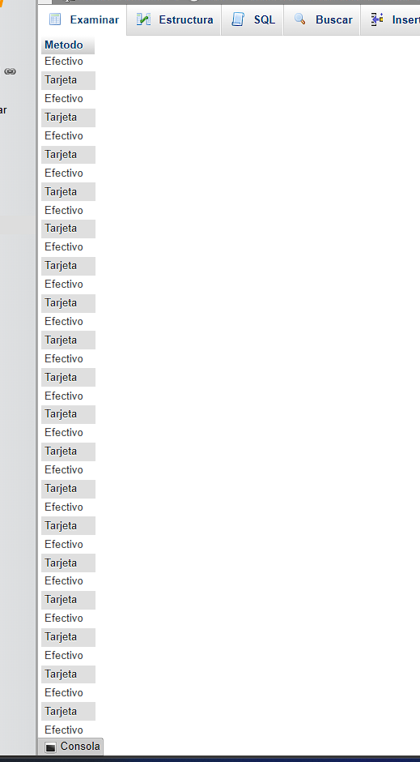

Venta:

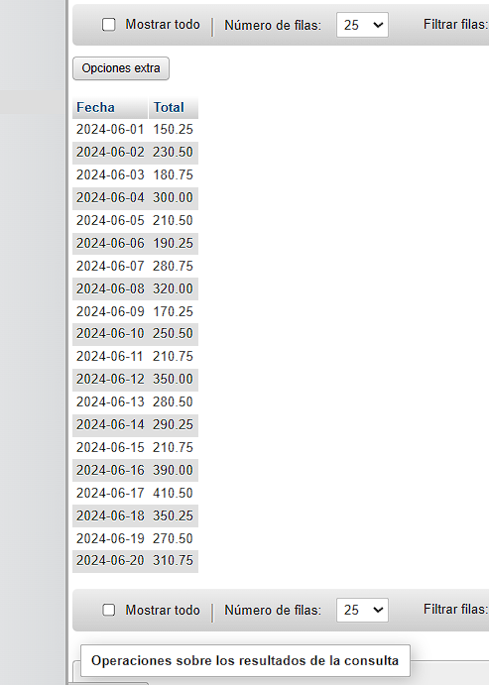

* 10 consultas sql

[SELECT](http://localhost/phpmyadmin/url.php?url=https://dev.mysql.com/doc/refman/8.0/en/select.html) * FROM venta WHERE Fecha = '2024-06-10';

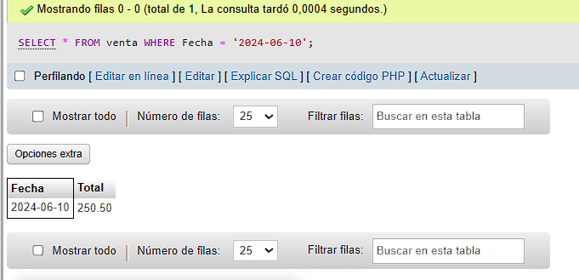

[SELECT](http://localhost/phpmyadmin/url.php?url=https://dev.mysql.com/doc/refman/8.0/en/select.html) * FROM proveedor WHERE Direccion [LIKE](http://localhost/phpmyadmin/url.php?url=https://dev.mysql.com/doc/refman/8.0/en/string-comparison-functions.html%23operator_like) '%Lima%';

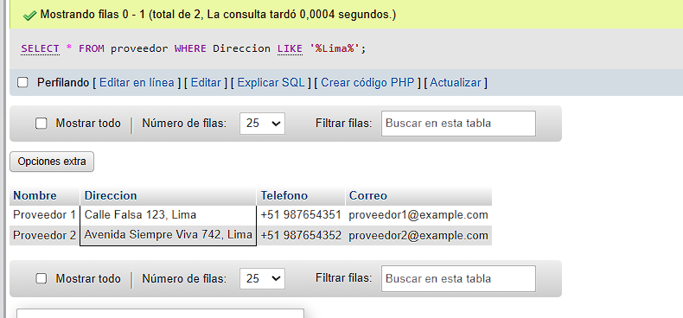

[SELECT](http://localhost/phpmyadmin/url.php?url=https://dev.mysql.com/doc/refman/8.0/en/select.html) * FROM detalleventa WHERE Cantidad > 3;

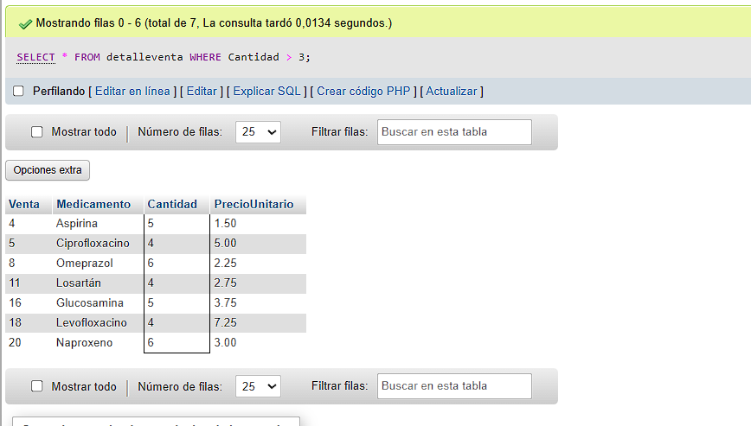

[SELECT](http://localhost/phpmyadmin/url.php?url=https://dev.mysql.com/doc/refman/8.0/en/select.html) * FROM detalleventa LIMIT 5;

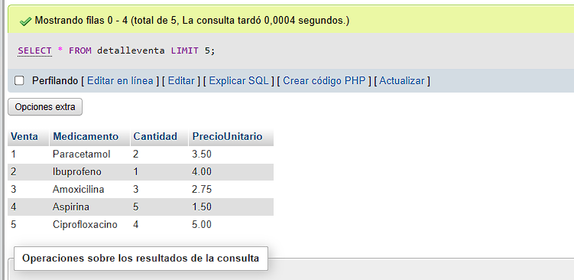

[SELECT](http://localhost/phpmyadmin/url.php?url=https://dev.mysql.com/doc/refman/8.0/en/select.html) DISTINCT Metodo FROM pago;

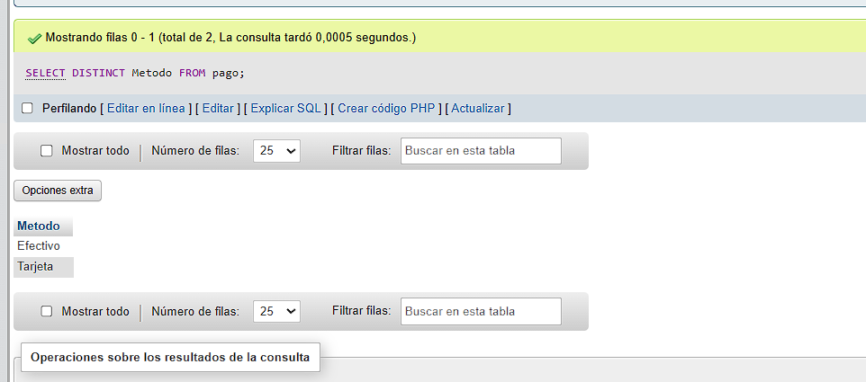

[SELECT](http://localhost/phpmyadmin/url.php?url=https://dev.mysql.com/doc/refman/8.0/en/select.html) SUBSTRING_INDEX(Direccion, ', ', -1) AS Ciudad, [COUNT](http://localhost/phpmyadmin/url.php?url=https://dev.mysql.com/doc/refman/8.0/en/aggregate-functions.html%23function_count)(*) AS NumeroProveedores FROM proveedor GROUP BY Ciudad ORDER BY NumeroProveedores DESC;

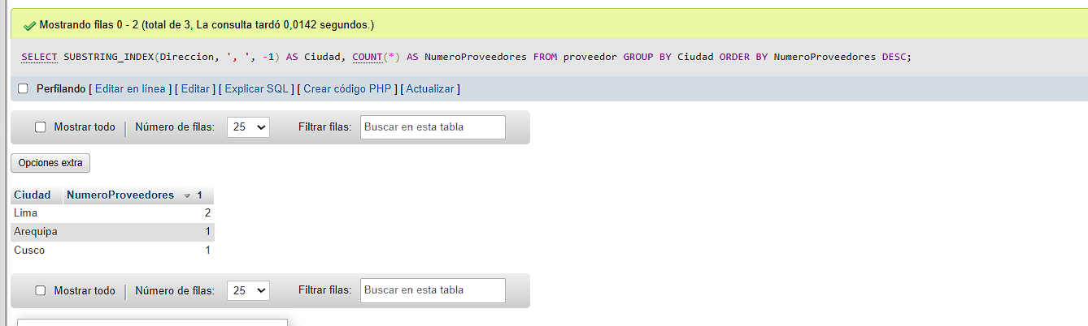

[SELECT](http://localhost/phpmyadmin/url.php?url=https://dev.mysql.com/doc/refman/8.0/en/select.html) Nombre, Correo FROM proveedor WHERE Nombre [LIKE](http://localhost/phpmyadmin/url.php?url=https://dev.mysql.com/doc/refman/8.0/en/string-comparison-functions.html%23operator_like) 'P%';

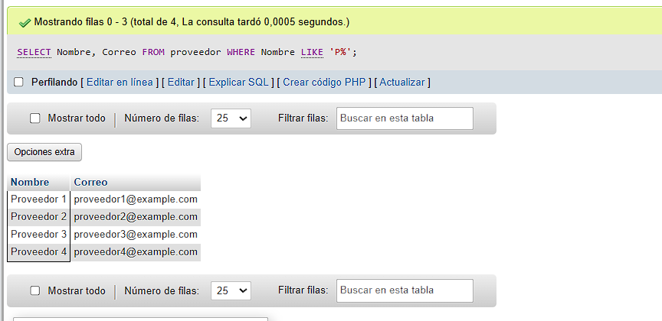

[SELECT](http://localhost/phpmyadmin/url.php?url=https://dev.mysql.com/doc/refman/8.0/en/select.html) Fecha, [SUM](http://localhost/phpmyadmin/url.php?url=https://dev.mysql.com/doc/refman/8.0/en/aggregate-functions.html%23function_sum)(Total) AS VentasTotales FROM venta GROUP BY Fecha ORDER BY Fecha;

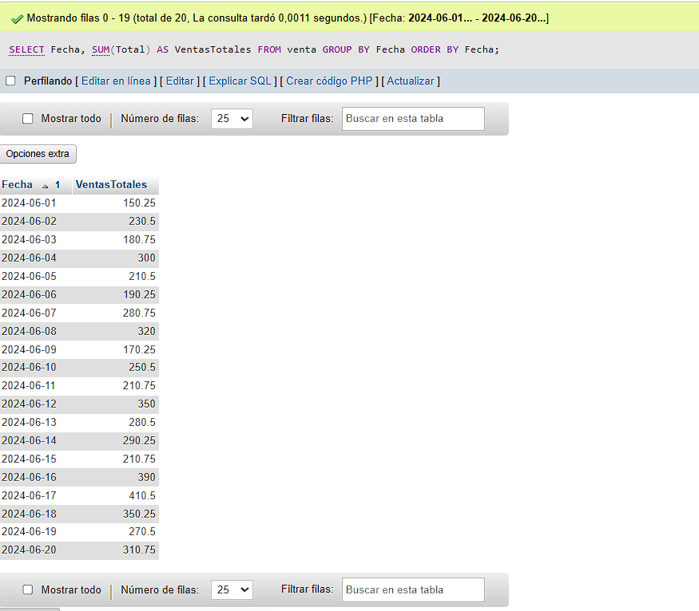

[SELECT](http://localhost/phpmyadmin/url.php?url=https://dev.mysql.com/doc/refman/8.0/en/select.html) * FROM clientes WHERE Numero [LIKE](http://localhost/phpmyadmin/url.php?url=https://dev.mysql.com/doc/refman/8.0/en/string-comparison-functions.html%23operator_like) '%5';

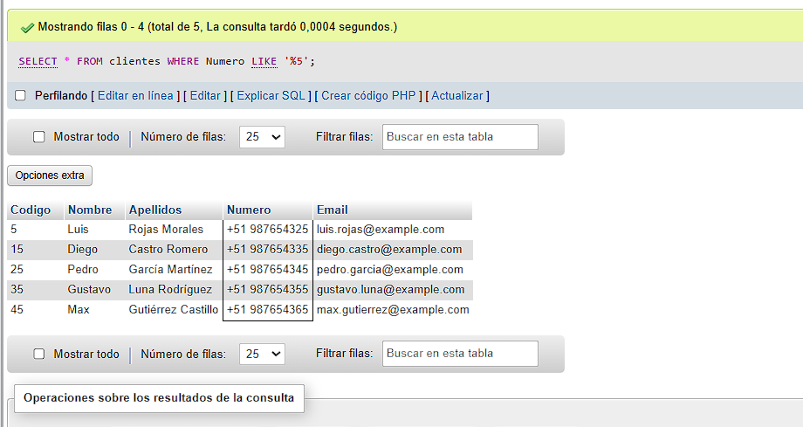

[SELECT](http://localhost/phpmyadmin/url.php?url=https://dev.mysql.com/doc/refman/8.0/en/select.html) MONTH(Fecha) AS Mes, [SUM](http://localhost/phpmyadmin/url.php?url=https://dev.mysql.com/doc/refman/8.0/en/aggregate-functions.html%23function_sum)(Total) AS VentasTotales FROM venta WHERE YEAR(Fecha) = 2024 GROUP BY Mes;

